

APPLICATION FORM FOR THE POST OF SIA STEWARD

Personal Details CONFIDENTIAL

Mr/Mrs/Miss/Ms | Surname:  First Name:

Address: ____________________________________________________________

Email Address: ______________________________________________________

Contact No: ________________________________________________________

Date of Birth: _____________________ Nationality: ______________________

Do you have any medical conditions: YES / NO
Do you take any medication: YES / NO
If yes please give details:

Do you hold any certificates for: SIA Badge: YES / NO
First Aid: YES / NO
SIA No: Fire-Fighting: YES / NO

Do you need a work permit to take up employment in the UK? YES? NO

Reference;

REHABILIATION OF OFFEDENFERS ACT 1974

Under the terms of the Rehabilitation of Offenders Act 1974, Safe-Tay Security Ltd request that you disclose all and any ‘unspent’ Convictions.

If you do not have ‘unspent’ convictions, please confirm this by specifying ‘None’ in the box below and sign and date the declaration.

Where the applicant has ‘unspent’ convictions please provide brief details of the nature of the conviction. All information provided will be kept in the strictest confidence and only used for the purpose of assessing your suitability for the post you have applied for.

‘Unspent’ Conviction(s) – please complete relevant section below

Yes (please provide brief details of the nature of the conviction)

No (please confirm by specifying “None” here) –

Signature of applicant: Date:

DECLARATION

I declare that the information given in this form, is to the best of my knowledge, true and complete.
I understand that if it is subsequently discovered any statement is false or misleading or that I have withheld relevant information, my application may be disqualified or, if I have already been appointed, I may be dismissed.

I hereby give my consent to Safe-Tay Security Ltd processing the data supplied on this application form for the purpose of recruitment and selection.

Name (print): Signature: Date:

HI VIS JACKET SIZE – please circle

SMALL /MEDIUM / LARGE / XLARGE / XXLARGE

Staff will be required to purchase a Branded Hi Visibility Vest from us, at a cost of £13.00 which is refundable on return should you leave the company.

FOR OFFICIAL USE ONLY

COPIES TAKEN

Yes No Expiry Date Type

SIA License ___________ _________

First Aid Certificate ___________ _________

Proof of Identification Type: ___________ _________

Proof of Address Type: ___________ _________

Right to work in UK Documents: __________________________

Disclosure

Date:

Interviewers Notes

Interviewer Signature :________________________________ DATE: ___________

Job Description – Safety Steward

Areas of Work; |  |  | Concourses  Vomitories  Stands  Trackside
Role; |  |  | Safety Steward
CRB check required; |  |  | No, unless working in family area
Qualifications; NVQ 2 Spectator Safety (or working towards)

These Stewards are not normally expected to be involved with searching or ejecting spectators.
Their role is one of customer care and they will be expected to call on a Supervisor or licenced stewards for assistance in dealing with breaches of Ground Regulations, searching or ejecting.

General requirements of a Steward
- You should be fit, active and have the character and temperament to carry out the duties of a Steward.
- You should possess good communication skills and be of sound character.
- You must be able to attend most first-team home fixtures and other major events held at the stadium.
- You should be polite, courteous and helpful to all supporters.
- Whilst on duty you will adhere to the Club dress code and be clean and tidy.
- You are not engaged to watch the game, but are expected to concentrate on your area of responsibility.
- You will not wear team colours whilst on duty.
- You should not, whilst on duty, eat, drink or smoke in view of the public.
- You should not consume alcohol before or during a tour of duty.
- You should never celebrate the team scoring a goal.
- You should never show hostility or use obscene or offensive language to any supporters.
- You should never act in any way likely to bring discredit on the Club.

Duties include;

- Attend the Stadium at given dates and times as dictated by the Safety Officer/Deputy Safety Officer or Chief Steward.
- Attend the pre-event briefing and ensure all information is understood.
- Do not leave the Stadium after ‘signing in’ until the end of your duties.
- Undertake pre-match and post match stand checks.
- To be responsible for the safety and comfort of spectators within a designated area at all times.
- Carry out pre match and post match safety checks as instructed by Supervisor.
- To staff entrances, exits and other key safety points within the Stadium.
- Constantly monitor the spectators in your area checking for signs of distress or overcrowding and take action in accordance with standing instructions
- Assist in the prevention of overcrowding by ensuring the crowd limits in various parts of the ground are complied with
- To control and direct spectators entering and leaving the Stadium and to assist in this movement.
- Ensure that gangways and exit/evacuation routes in your area are kept clear.
- Identify and investigate any incident or occurrence among spectators reporting findings to a supervisor. Where appropriate complete the relevant Incident/Offence Report.
- Enforce and immediately report any breach of the Ground Regulations to Supervisor.
- Know the location of and be able to operate effectively the fire-fighting equipment at the Stadium.
- Be able to provide basic First Aid if required.
- Know the location of the First Aid Rooms located within the Stadium.
- Be fully conversant with any methods or messages used to alert staff that an emergency has arisen.
- Be capable of recognising potential fire hazards and suspect packages, reporting such matters immediately to a Supervisor, Chief Steward, Deputy Safety Officer or Safety Officer.
- Promptly comply with any instruction given by a Supervisor, Chief Steward, Deputy Safety Officer, Safety Officer or Police Officer.
- Remain at allocated post as instructed unless authorised or ordered to do otherwise by a Supervisor, Chief Steward, Deputy Safety Officer, Safety Officer or Police Officer.
- Report immediately to a Supervisor, Chief Steward, Deputy Safety Officer or Safety Officer any damage or defect which is likely to pose a threat or danger to spectator safety eg damaged seat or barrier.
- Assist as required in the evacuation of spectators etc from the Stadium.
- Comply with the relevant instructions and guidance contained in the Stewards Operational Handbook.
- To undertake specific duties in an emergency or as directed by the Safety Officer, Deputy Safety Officer or the appropriate emergency services officer
- Attend all required training

Football Steward Dress Code;
Black or white polo-shirt/shirt and tie, black trousers and black shoes/boots.
You will be supplied with a hi-vis jacket or vest on the day.
If this dress code has not been adhered to, you may be turned away for work.

• To understand their general responsibilities towards the health and safety and welfare of all spectators, other stewards ground staff and themselves

Name: ............................................................. Date: ..................................

Print Name: .....................................................

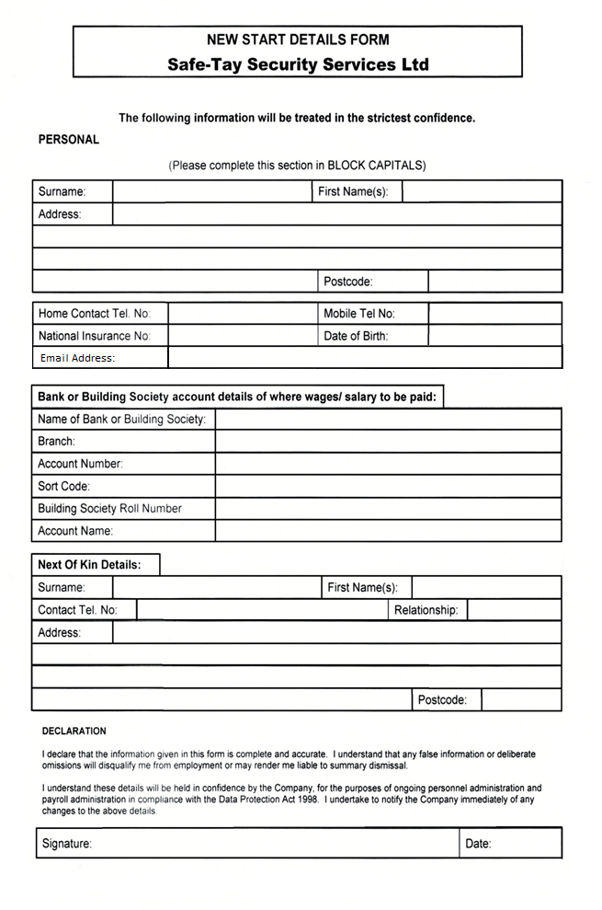

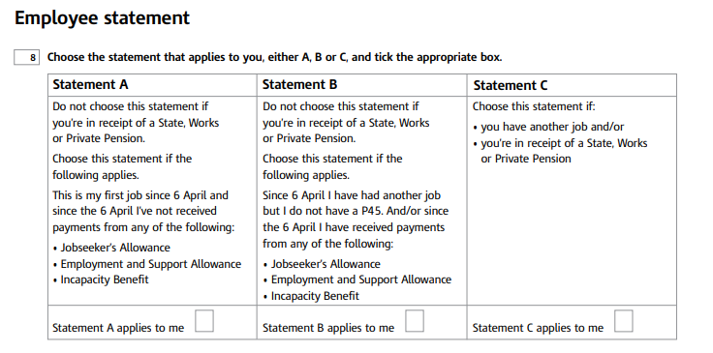
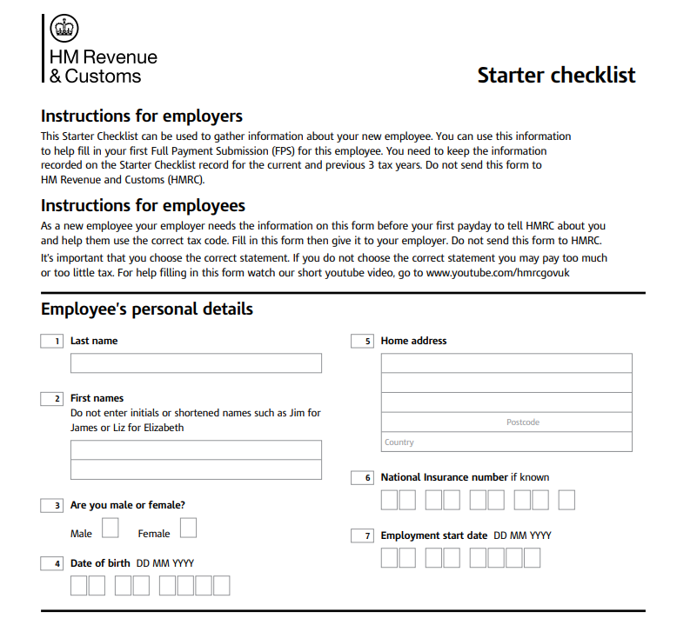

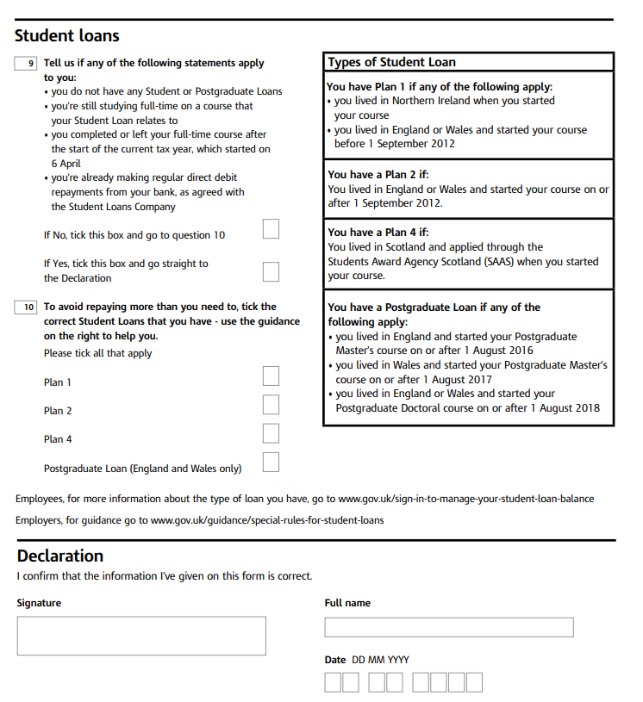


SAFETY CARD

SAFETY OFFICER ERIS - STADIUM EVACUATIONS
In the event of a Stadium Evacuation being considered, the following message will be broadcast over the stadiums public announcement system:
"Would Safety Officer Eris please contact the control room immediately" - (This message will typically be repeated twice)
Upon hearing this message, stewards should:
- If positioned on an Entry turnstile, immediately cease access to the stadium by standing within the stile preventing public access.
- If position on an Exit Door or Fire Exit, immediately OPEN the door securing the door in a locked open position.
- If positioned within a Lower Tier stand, make your way immediately to track side facing the crowd.
- If positioned in an Upper Tier stand, make your way to the front of the upper tier by the exit stairs.
By ensuring that the above steps have been done, we are now in a position to, if needed evacuate the stadium.
Should the call be made to evacuate:
There will be a message broadcast over the stadiums public announcement system instructing the public to exit the stadium via their nearest available exit whilst following the instructions of Stewards and Police in a controlled manner. Stewards are then responsible for guiding the public out of the stadium through the appropriate exits, ensuring that the stadium stands are empty.
No Need to Evacuate?
Should there be no need to evacuate the stadium, the following message will be broadcast: "Would all stewards please return to their duties"
Stewards should then return to normal duties, securing any open doors.

FIRE - EMERGENCIES - INCIDENTS - EVACUATIONS
IN THE EVENT OF AN EMERGENCY OR INCIDENT, THE SENIOR POLICE OFFICER PRESENT WILL TAKE COMMAND AND ALL STEWARDS SHOULD PROMPTLY COMPLY WITH ANY INSTRUCTIONS GIVEN BY THEM OR ON THEIR BEHALF.

Fire:
Should a fire be confirmed with the ground, the stewards will ensure that all exit gates are fully opened and fixed in that position by hooks and eyes provided for that purpose.
Stewards are to be familiar with the location and operation of all firefighting equipment within the ground. Senior Stewards are to be responsible for ensuring that the stewards under their control have this knowledge.
Stewards should be capable of recognizing potential fire hazard and suspect packages and report such findings immediately to a supervisor and/or a Police Officer.

STEWARD INDUCTION TRAINING
You are required to complete our Steward Induction Training via our Learner EdApp LMS.



Please complete the INDUCTION TRAINING and send your Certificates of Completion to:
Lee Copland - lee@safe-taysecurity.co.uk

ACT Awareness & ACT Security Counter Terrorism Courses
As part of our continued commitment to our employee development, we are requesting all our staff complete the ACT Awareness & ACT Security Terrorism Modules.

ACT Awareness & ACT Security is free, specialised training for front line security operatives and those that work within public space events.

The custom-built training provides up-to-date counter-terrorism knowledge to help operatives prepare for and respond to terrorist incidents whilst on duty.

You can access this training throughout website and following the onscreen instructions:
https://www.safe-taysecurity.co.uk/ACT/



