 | SAFE-TAY SECURITY SERVICES LTD  APPLICATION FORM
  Reference | SF 01
  Version | 1.2
  Issue Date | 14/06/2023
  Approved | MD

SAFE-TAY SECURITY SERVICES LTD |  | VETTING FROM: / /  VETTED BY:  (12/16 weeks from  the above date). / /
PLEASE  AFFIX  PHOTOGRAPH | S.I.A. LICENCE NUMBER:………………………………………..  EMPLOYMENT AS: SECURITY OFFICER/PERSONNEL  CONFIDENTIAL WHEN COMPLETED

PLEASE ANSWER ALL QUESTIONS USING BLOCK CAPITALS

1. PERSONAL INFORMATION

SURNAME: |  | FIRST NAMES;

CURRENT  ADDRESS: |  | TELEPHONE:  MOBILE NO:
PREVIOUS  ADDRESS  IF LESS THAN  3 YEARS AT  ABOVE, |  | CURRENT DRIVING LICENCE: NO;
PREVIOUS  ADDRESS  IF LESS THAN  3 YEARS AT  ABOVE, |  | CAR OWNER: | YES NO (delete)
PREVIOUS  ADDRESS  IF LESS THAN  3 YEARS AT  ABOVE, |  | NATIONAL  INSURANCE No

Email Address :

2. PLACE OF BIRTH: IN THE UK

MARITAL  STATUS: | MARRIED | DIVORCED | SINGLE  OR OTHER | HOW DID YOU HEAR ABOUT THE ROLE

3. PERSON/NEXT OF KIN TO BE CONTACTED IN ANY EMERGENCY:

NAME:  ADDRESS: |  | RELATIONSHIP:  TELEPHONE NUMBER:

HEIGHT: |  | WEIGHT: |  | COLOUR OF EYES:

4. HAVE YOU EVER APPEARED BEFORE A COURT CHARGED WITH A CRIMINAL, CIVIL OR MILITARY OFFENCE AND BEEN CONVICTED INCLUDING ANY MOTORING OFFENCES HAVE YOU ANY ALLEGED OFFENCES OUTSTANDING.

YES | NO | IF YES, GIVE DETAILS:

5. PERSONAL HISTORY (PART A)

The security screening process requires that we are able to verify your personal history for a period of ten OR FIVE years or to date of leaving school. Please give details of your personal history, identify in the space provided all periods of EMPLOYMENT SELF employment, registered or unregistered unemployment (state the unemployment office which you reported to), military service. Be sure to give full addresses including, telephone numbers and dates.

EMPLOYERS NAME,  ADDRESS | NAME OF THE PERSON  YOU REPORTED TO. | POSITION YOU HELD | EMPLOYMENT  DATES INCLUDE  MONTHS | REASON  FOR  LEAVING
TELE No: |  |  | START  END |  | 1
TELE No: |  |  | START  END |  | 2
TELE No: |  |  | START  END |  | 3
TELE No: |  |  | START  END |  | 4
TELE No: |  |  | START  END |  | 5
TELE No: |  |  | START  END |  | 6
TELE No: |  |  | START  END |  | 7

- PERSONAL HISTORY (PART B)

IN THE CASE OF PERIODS OF SELF-EMPLOYMENT PLEASE GIVE NAMES AND ADDRESSES OF SOMEONE WHO CAN CONFIRM YOU’RE DETAILS (ie; BOOKKEEPER, ACCOUNTANT, and OR SOLICITOR).

HAVE YOU BEEN MADE BANKRUPT? YES/NO DO YOU HAVE ANY COUNTY COURT JUDGEMENTS? YES/NO

DO YOU OBJECT TO THE COMPANY CONTACTING A CREDIT AGENCY

WITH REFERENCE TO YOURSELF? YES/NO

7. DETAILS OF WHEN YOU LEFT SCHOOL & IF YOU ATTENDED COLLEGE IN THE

LAST 10 YEARS

SCHOOL NAME: (secondary only) | TOWN/CITY: | DATE YOU LEFT SCHOOL: | COLLEGE & DATES:

Employees working on night duties may be required to undertake a medical, for further information contact head office

READ THIS SECTION CAREFULLY BEFORE YOU SIGN THE STATEMENT

1. IF OFFERED EMPLOYMENT IT WILL BE INITIALLY FOR A PROBATIONARY PERIOD OF 16 WEEKS.
AFTER A PERIOD OF 12 WEEKS FROM START DATE FOR SCREENING:

2. DURING THE PROBATIONARY PERIOD YOUR CONTRACT OF EMPLOYMENT MAY BE TERMINABLE BY THE "COMPANY" BY NO LESS THAN 24 HOURS NOTICE IN WRITING. THIS APPLIES TO SCREENING PERIOD ALSO.

- CONTINUED EMPLOYMENT IS CONDITIONAL UPON SATISFACTORY SCREENING,

- WE COMPLETE SOCIAL MEDIA AND INTERNET SEARCHES ON ALL APPLICANTS TO INTENTIFY ILLEGAL ACTIVITY INCLUDING BUT NOT EXCLUSIVLY HATE CRIME

STATEMENT TO BE SIGNED BY APPLICANT

I _________________________CERTIFY THAT TO THE BEST OF MY KNOWLEDGE, THE INFORMATION I
HAVE GIVEN IS COMPLETE AND CORRECT, AN I UNDERSTAND THAT MISREPRESENTATION OF FACTS IS GROUNDS FOR IMMEDIATE DISMISSAL AND RENDERS ME LIABLE FOR PROSECUTION.
I AUTHORISE THE COMPANY TO APPROACH ANY GOVERNMENT AGENCIES, FORMER EMPLOYERS, CREDIT AGENCIES AND PERSONAL REFEREES TO VERIFY THE INFORMATION GIVEN AND WILL SUPPLY A STATUTORY DECLARATION IF REQUIRED (I GIVE PERMISSION FOR MY PRESENT EMPLOYER TO BE APPROACHED). I CONFIRM IF SUCCESSFUL

APPLICANTS SIGNATURE: _______________________________________DATE:_______________________

ADDITIONAL INFORMATION
(PLEASE USE THIS SECTION TO SUPPLY ANY OTHER RELEVENT INFORMATION)

Please provide email addresses for your work-checkable history here:

Notice to all Applicants

SAFE-TAY SECURITY SERVICES LTD Conforms to the Standard of BS 7858:2019 and as such all applicants must undergo a security screening process.

- The application must be completed in full.

- A full 5 year work history (or in the case of a younger applicant a 10 year if the company requires the later for client or insurance reasons.
- Personal references
- Proof of I D
- Proof of address
- Medical history
- National Insurance Check
- Criminal Records Bureau Screening via the S.I.A.

As to enable us to process your application please supply the following in full

- Full names, addresses and telephone numbers of previous employers
- Full names, addresses and telephone numbers of personal references
- Full details of any unemployment

Please bring the following items to your interview

- Birth certificate
- Passport (if held)
- Two recent utility bills
- Driving licence (if held)
- Two passport size photographs
- Bank details
- P45 if you have one

Failure to complete this application form could result in your application being delayed or rejected. Any information supplied that is found to be fraudulent would result in dismissal or in some cases legal action being taken.

Before proceeding with this application

- Do you agree to a S.I.A. Criminal record check being carried out? YES/NO

- Do you fully understand the potential consequences? YES/NO

- Do you agree to a credit check taken via a credit agency regards to yourself YES/NO?

Print Name_______________________

Signature________________________

Date ___________________________

FOR OFFICE USE ONLY

Associated Documents: Seen: Date: Copy Retained:
Yes No
Birth Certificate/Passport

S.I.A. Licence

Service Record

Utility Bill/Bank Statement

NOTE: PHOTOCOPIES OF ONE THE ABOVE DOCUMENTS ARE TO BE INCLUDED WITHIN VETTING PAPERS.

I HAVE CHECKED THE DETAILS OF THIS APPLICATION FORM AND CONFIRM THAT ALL
INFORMATION IS CORRECT AT TIME OF INTERVIEW.

PRINT NAME……………………………………………… SIGN………………………………………

SOCIAL MEDIA CHECK FINDINGS

INTERNET SEARCH FINDINGS

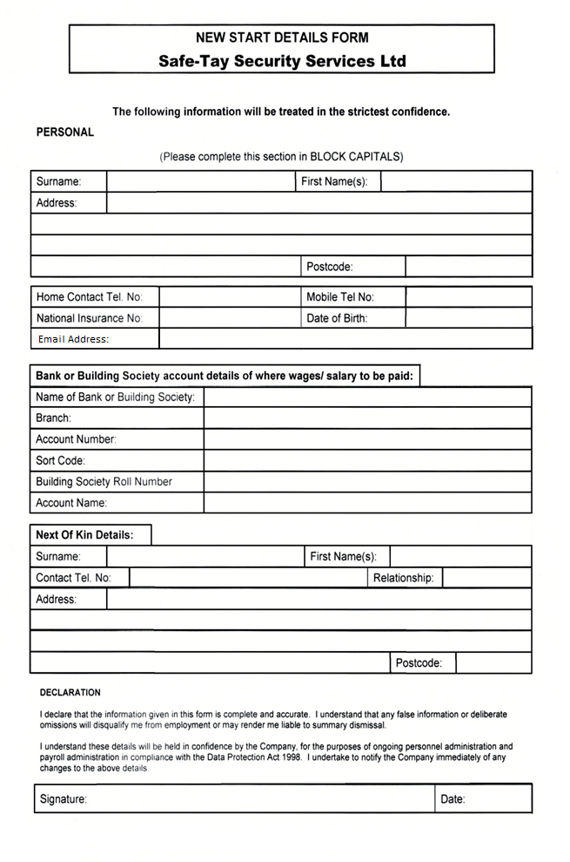
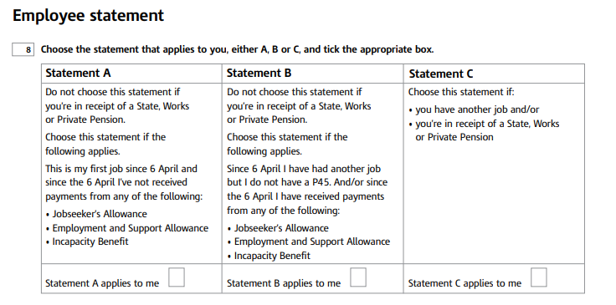
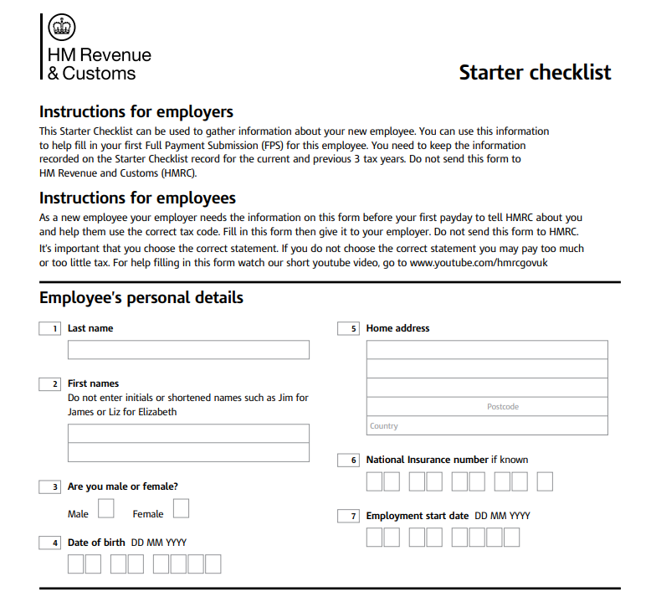

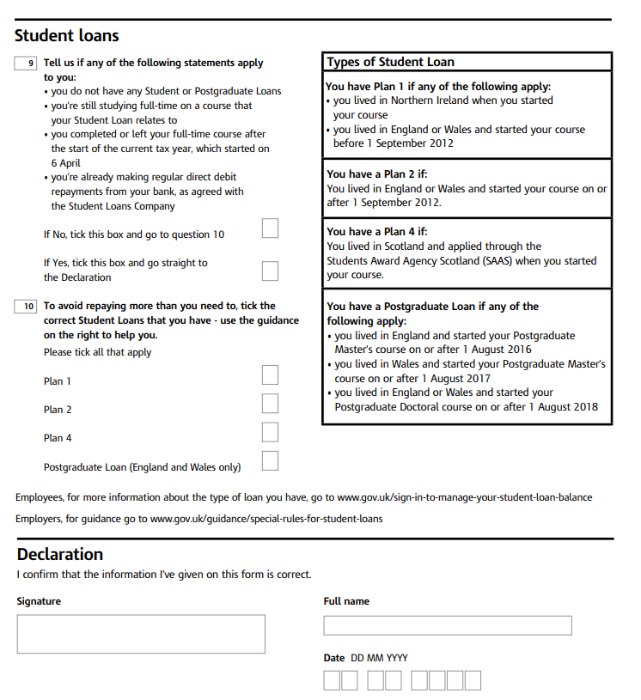

Once you have completed our Application Pack,
please contact our office to arrange an interview appointment.

Telephone: 01382 322330
Email: office@safe-taysecurity.co.uk

You will be required to bring with you the following documents:
2 x proof of address
(Bank statement / Utility Bill dated within the last 3 months)

Your physical SIA Licence

Disclosure Scotland Criminatlity Certificate
This is the Criminatlity Certificate you were provided as part of your SIA Application.

Proof of Identification
Passport / Driving Licence

Driving Licence
If you hold a valid full UK or EU Driving Licence please bring this with you.
NOTE: You must complete the Stewarding Competency Training through EdApp prior to returning your application to us. As part of our recruitment process, you will undergo a 2-page open response questionnaire against the content covered in EdApp. Where an applicant has not undertaken this action, an appliation will not be processed.

If you are an oversea resident/student, we will requre a Right to Work Check Code

COMPULSORY STEWARD TRAINING

As part of our ongoing staff development commitment, all applicants MUST complete the following onboarding as part of our Application Process.

Topic 1: Theory Based learning through our EdApp Platform covering the job role, responsibilities and requirements.

Topic 2: Specialised eLearning for front line operatives and those that work within public space events - provided through the Protect UK Website covering topics surrounding Terrorism.

Assessment: You will be required to undertake an unassisted Theory Based Knowledge Assessment covering Topics 1 & 2 when you return your completed application to us.

Instructions are provided on our website by scanning the QR Code on how to access both training topics: | 

